1. SEGMENTATION:
Segmentation is a memory-management scheme that supports the programmer view of memory.
- A logical address space is a collection of segments.
- Each segment has a name and a length.
- The logical addresses specify both the segment name and the offset within the segment. Each address is specified by two quantities: a segment name and an offset
    - <Segment-number, offset>.
- A C compiler might create separate segments for the following:
    - 1. The code
    - 2. Global variables
    - 3. The heap, from which memory is allocated
    - 4. The stacks used by each thread
    - 5. The standard C library
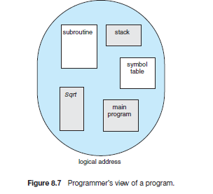
SEGMENTATION HARDWARE:
- The programmer can refer to objects in the program by a two-dimensional address (segment number and offset); the actual physical memory a one dimensional sequence of bytes.
- The two-dimensional user-defined addresses should be mapped into one-dimensional physical addresses.
- The mapping of logical address to physical address is done by a table called segment table.
- Each entry in the segment table has a segment base and a segment limit.
- The segment base contains the starting physical address where the segment resides in memory
- The segment limit specifies the length of the segment.
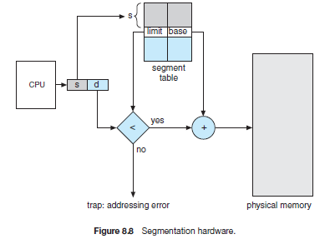
- A logical address consists of two parts: a segment number, s, and an offset into that segment, d.
- The segment number is used as an index to the segment table. The offset d of the logical address must be between 0 and the segment limit.
- If it is not between 0 and limit then hardware trap to the operating system (logical addressing attempt beyond end of segment).
- When an offset is legal, it is added to the segment base to produce the address in physical memory of the desired byte.
- The segment table is an array of base–limit register pairs.
- Segmentation can be combined with paging.
- Example: Consider five segments numbered from 0 through 4. The segment table has a separate entry for each segment, giving the beginning address of the segment in physical memory (or base) and the length of that segment (or limit).
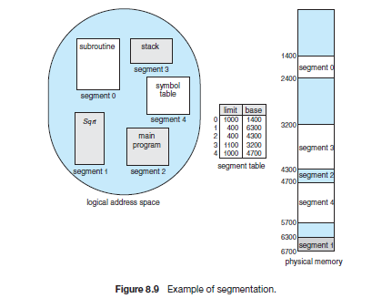
- The Segment 2 is 400 bytes long and begins at location 4300. Thus, a reference to byte 53 of segment 2 is mapped onto location 4300 + 53 = 4353.
- A reference to segment 3, byte 852, is mapped to 3200 (the base of segment 3) + 852 = 4052.
- A reference to byte 1222 of segment 0 would result in a trap to the operating system, as this segment is only 1,000 bytes long.

